Mike McLaughlin
International Selective Description
April 10, 2008

In August 2007 I had the distinct privilege of joining nearly 35 other physicians, medical students, dentists, and volunteers on a 1 month expedition to northern India with the Himalayan Health Exchange. It was a truly wonderful experience that left me with many cherished memories and inspired me to do further work abroad in the future.
I first found out about the Himalayan Health Exchange through an internet search looking for international opportunities for my selective. HHE runs many different trips throughout the year, all of which serve the mountainous regions of northern India. I joined the Kargiakh trip, which ran throughout the month of August. The University of Arizona emergency medicine residency was very accommodating with the scheduling and assisted me with one of the departments annual travel grants.
Our trip began in Delhi and we quickly flew to Leh, which is a beautiful mountain city in the Buddhist region of Ladakh. We acclimatized here, played tourist, and prepared for our trip. Following this, we traveled two days by bus to the start of our trek. From here, we commenced upon a nearly 3 week trek through the Zanskar mountains. Our itinerary was typically to trek for one day and then stop in a village and set up clinic for a day. On clinic days we would see dozens and even hundreds of patients from the villages. As one of only five physicians on the trip, I had the wonderful experience of being able to supervise four or five medical students per day. Our most common complaints were chronic conditions such as dyspepsia and osteoarthritis. However, I was able to see many interesting acute complaints, such as severe anemia, tuberculosis, rheumatic heart disease, amebic dysentery, probable appendicitis, orbital cellulitis, lacerations, and abscesses. We had no lab supplies beyond urine dipsticks and pregnancy tests and no radiology capabilities. Therefore, it was refreshing to rely upon my H&P and clinical judgment. We could only offer medicines and education, yet I felt as though we were making a difference. Patients with problems beyond our capabilities were referred to the nearest hospital. For patients that needed further non-emergency treatment by a specialist, we referred them to the HHE’s bi-annual camps in Leh and other large cities when they arrange for many medical and surgical specialists to volunteer their services to the people of the region who were seen originally on one of the HHE trips
In addition to seeing patients in the small villages, we came across many other trekkers with complaints ranging from altitude illness to pneumonia. I was able to learn quite a bit from altitude illness on this trip. Our trip leader held a particular expertise in this subject and he was able to teach me a lot about this fascinating topic. In the evenings on clinic days someone from the group gave a short 20-30 minute lecture on a pertinent topic and we discussed interesting cases. I presented a talk about pediatric diarrhea and dehydration.
Trekking through the Himalayas offered no shortage of stunning views and magical moments. No computers, showers, email, phone calls, voicemails, traffic, or hassles for 3 weeks. Just mountain streams, stunning peaks, wonderful weather, and good people. It was therapeutic. I was privileged to meet so many interesting people from all over the world. I stay in touch with several to this day. Our group came from all over the USA as well as England, Scotland, France, Australia, Canada, Nepal, and India. At the conclusion of our trek we were all able to travel together for various amounts of time throughout India, seeing more of that amazing country and enjoying each other’s company.
In summary my journey with the Himalayan Health Exchange was one of my most memorable experiences to date. I recommend the organization without hesitation to anyone looking for a similar experience.
The Himalayan Health Exchange is based out of Decatur, GA. Their website address is:

http://www.himalayanhealth.com/

Their general email is:

info@himalayanhealth.com

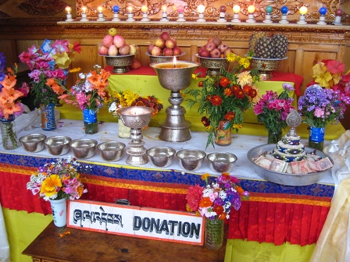 | 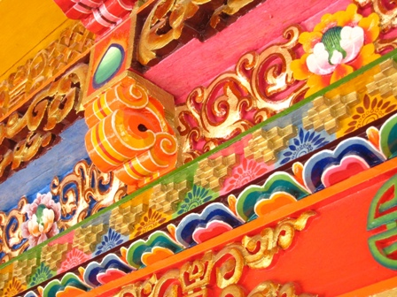
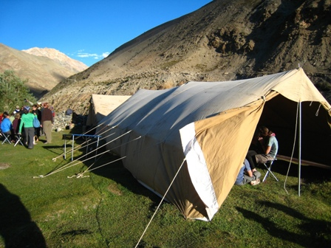 | 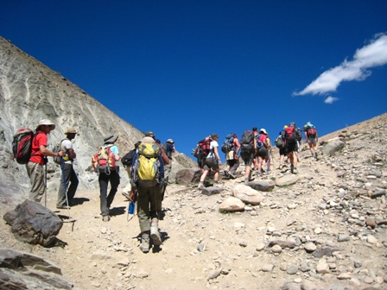
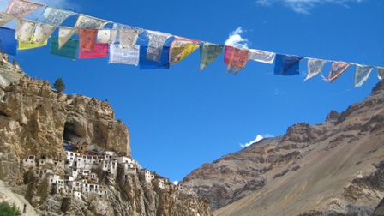 | 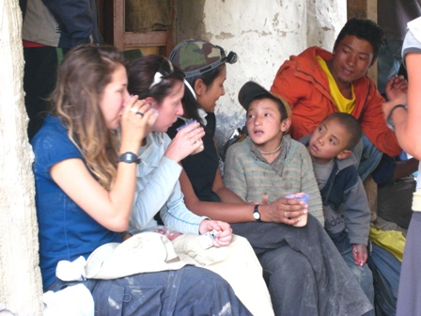
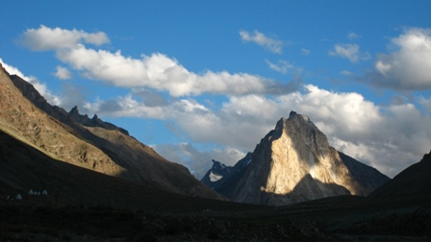 | 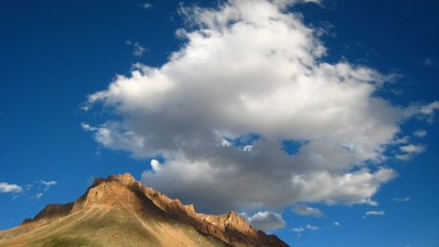
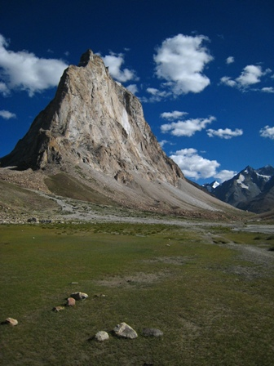 | 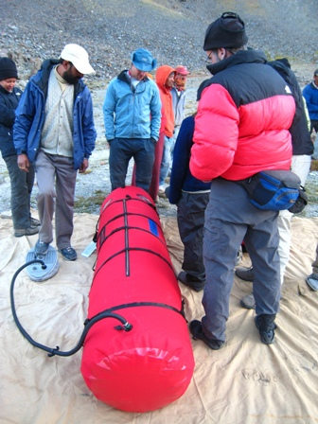
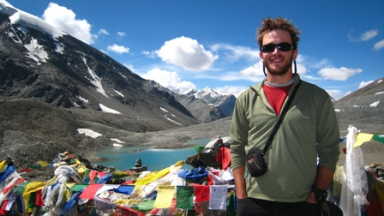 | 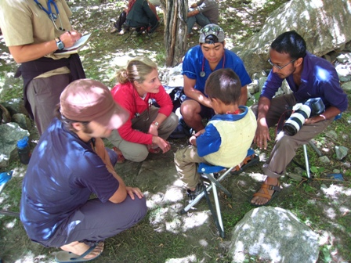
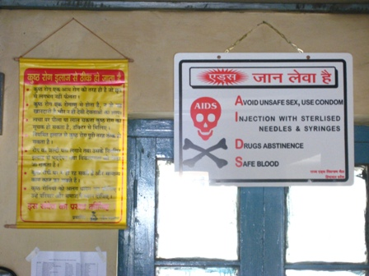 | 

